Lab: SPSS Modeler in DSX

November 30th, 2017

Author: Elena Lowery elowery@us.ibm.com
Table of contents
Contents
Overview 1
Required software, access, and files 1
Part 1: Create a DSX Project and Load Data 1
Part 2: Import an existing SPSS Modeler Stream 2
Part 3: Create a Stream 6

Telco Churn 6

Overview
In this lab you will learn how to implement analytics in the SPSS Modeler interface of Data Science Experience.
While knowledge of SPSS Modeler is not required to complete this lab, we don’t explain the basics of working in Modeler UI. Please see SPSS Modeler documentation for detailed information: https://www.ibm.com/support/knowledgecenter/SS3RA7_18.1.1/modeler.kc.doc/clementine/knowledge_center/product_landing.html
If you’re completely new to analytics, this article provides a brief explanation of model types: https://www.ibm.com/support/knowledgecenter/SS3RA7_18.1.1/modeler_mainhelp_client_ddita/clementine/getstart_mod_tech.html#getstart_mod_tech

Required software, access, and files

- To complete this lab, you will need access to a DSX Local cluster.
- You will also need to download and unzip this GitHub repository: https://github.com/elenalowery/DSX_Local_Workshop

Part 1: Create a DSX Project and Load Data

- Log in to a DSX Local cluster.

- Create a project. You can provide any name. In DSX Local project names must be unique within in a cluster. For example, add initials to the name of your project.

  - If you already loaded DSX_Local_Workshop project, then you can add a Modeler Stream to it.

- Switch to the Assets tab. Scroll to Data Sets and click on add data set.

- Click Browse. Navigate to the SPSS Modeler/data folder of the unzipped GitHub repository and import files.

  - If you already imported the DSX_Local_Project, then all files with the exception of NBA_Input_Customer.csv and NBA_Input_Offers.csv are already loaded. You can just load these files.

  - If you accidently overwrite other files, that’s not an issue – we use the same data for notebooks and Modeler streams.

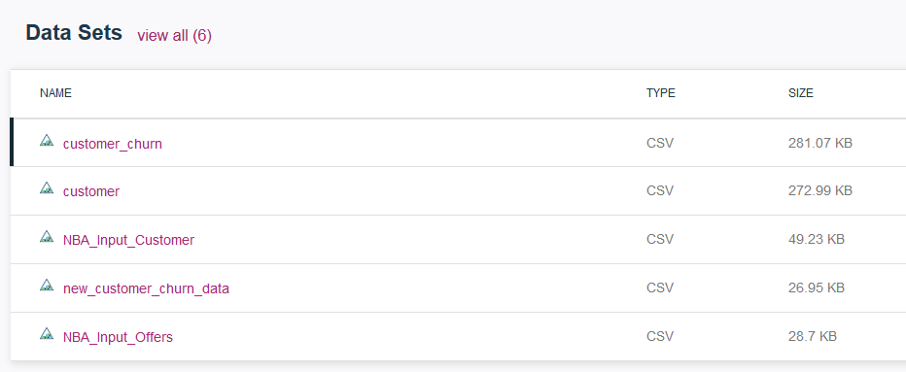

Part 2: Import an existing SPSS Modeler Stream

In this section we will upload a stream that was previously created in SPSS Modeler desktop.

- In the project scroll down to SPSS Modeler and click add stream.

- Enter a unique Stream name (for example, add your initials): NextBestOffer_el.

- Select From file and browse to the SPSS Modeler/streams folder of the unzipped file that you downloaded from GitHub.

- Select NextBestOfferAssociationAndPredictive.str and click Create.

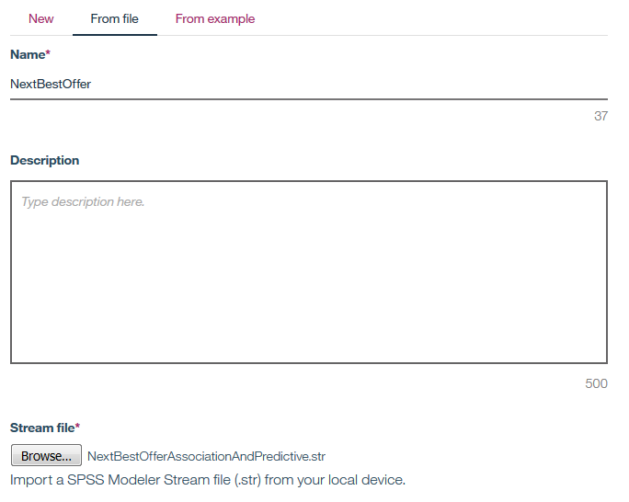

- The imported stream will look similar to the following screenshot.

This stream implements 2 use cases:
- Recommend the top 3 offers (association model) for each customer
- Recommend the best channel for contacting the customer (decision tree model)
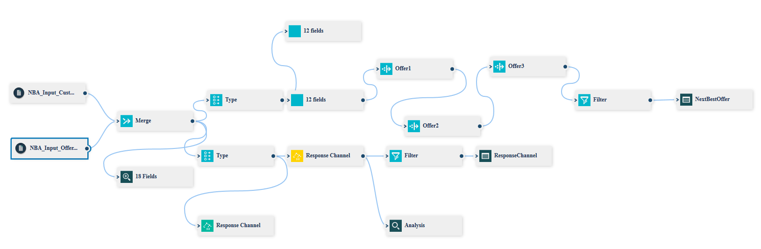

Note: No picture on the icon means that the node is not yet supported in the DSX/Modeler UI. However, the Modeler Stream will still run and execute this node. For example, in the stream we are using the association model is not yet implemented in the UI, but we can still run the stream.

- Before we can run this stream, we need to change the Source (input data) nodes. Delete the two NBA_Input… source nodes. In the imported stream the source nodes point to local file system.

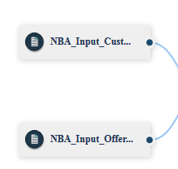

- Click on the Data icon and from the Files tab drag the two NBA… files onto the canvas.

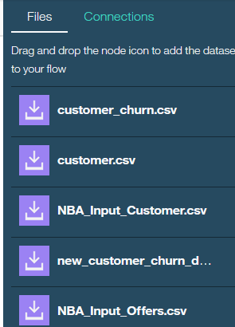

- Connect the input files to the Merge node.

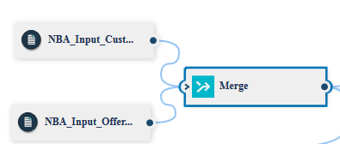

- We are now ready to run the stream. You can run each individual branch of the stream by selecting the terminal (end) node and clicking the Run (arrow) icon.

  - For example, click on the Next Best Offer output field at the end of the main branch (on the right)

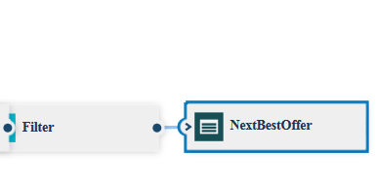
  - Or, you can run the entire stream, which will create output from all branches, by selecting the run icon (arrow) on the menu bar.

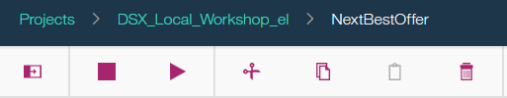

- Output can be viewed by selecting the Outputs tab and double clicking on the output you’d like to view.

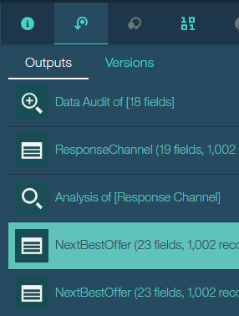

NextBestOffer and ResponseChannel outputs show the scoring results.

Double click on NextBestOffer to review recommendations for each customer.

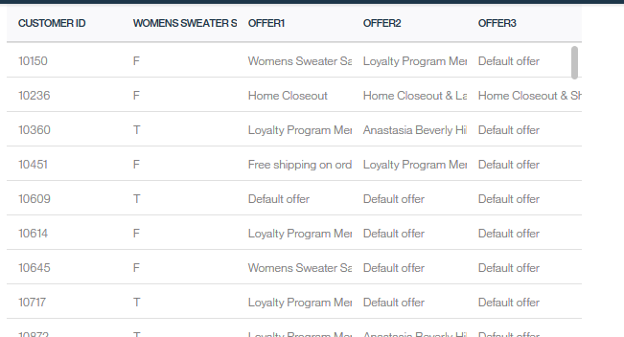

Double click on ResponseChannel to view recommendations for a marketing channel.

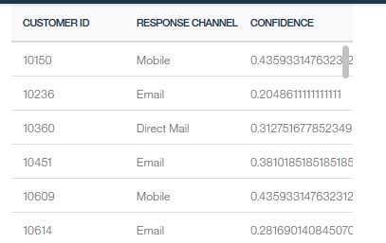

Note: At this time SPSS stream deployment capabilities are not yet available in DSX Local. When deployment capabilities are available, you will be able to deploy the Modeler stream for batch and online scoring.

After you’re done reviewing the stream, navigate back to the project.

Part 3: Create a Stream

In this section you will create a Modeler stream in DSX/Modeler UI. The process is the same as creating a Modeler stream in SPSS Modeler desktop, the only differences are in the UI look and feel and runtime environment (DSX).

As explained earlier, if you need more information about SPSS Modeler, refer to SPSS Modeler Knowledge Center documentation.

We provide instructions for the following use case:
- Telco churn: uses the same data and implements the same use case as Jupyter and Zeppelin Telco Churn notebooks.

Telco Churn

- On the Assets tab scroll down to SPSS Modeler and click add streams.

- Provide a unique stream name (for example, add your initials) TelcoChurn_el. Click Create.

- Drag and drop customer and churn data source to the canvas.

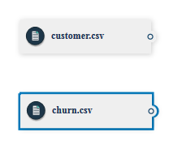

- Right mouse click on the data sources in the canvas and select Preview to view the data. Preview is accessible through the Outputs tab.

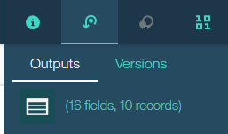
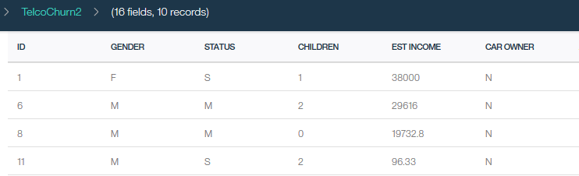

- Click on the Palette icon and expand Record Operations.

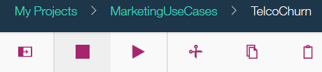

- Add the Merge node then connect the customer and the churn data sources to it.

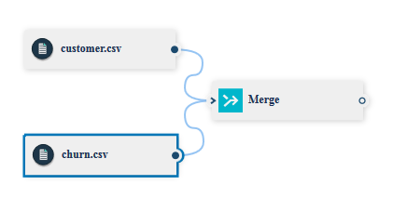

- Double click on the Merge node. Select Keys as the Merge method.

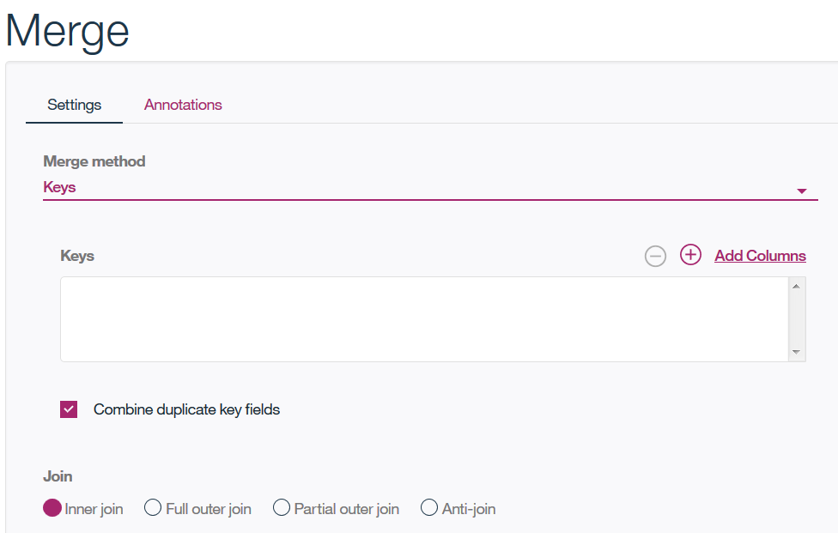

- Click Add Columns and select the ID filed. Click Select Fields for Merge to return to the previous screen.

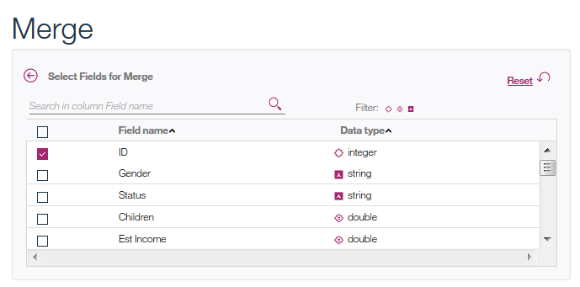

- Now the Merge screen looks like the following screenshot. Click OK.

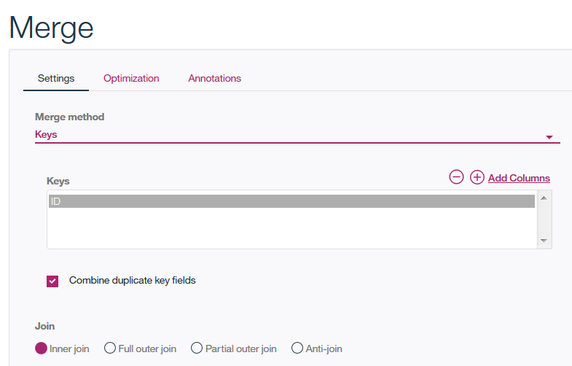

- Next, you can connect the merged data to different types of graphs to get a better understanding of data. For example, you can add a Distribution graph and display churn by gender.

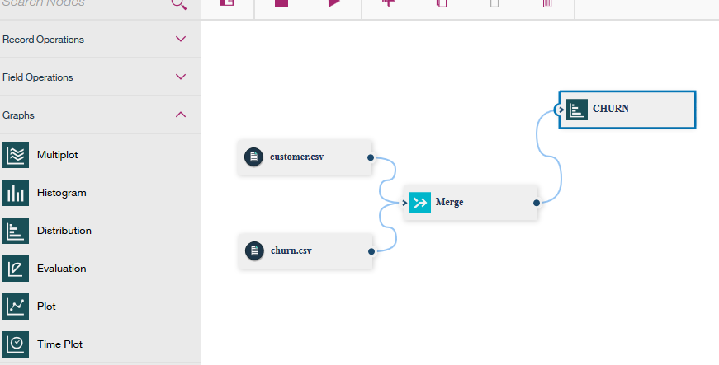

- Double click on the Distribution node to edit it. Then right click and select Run.
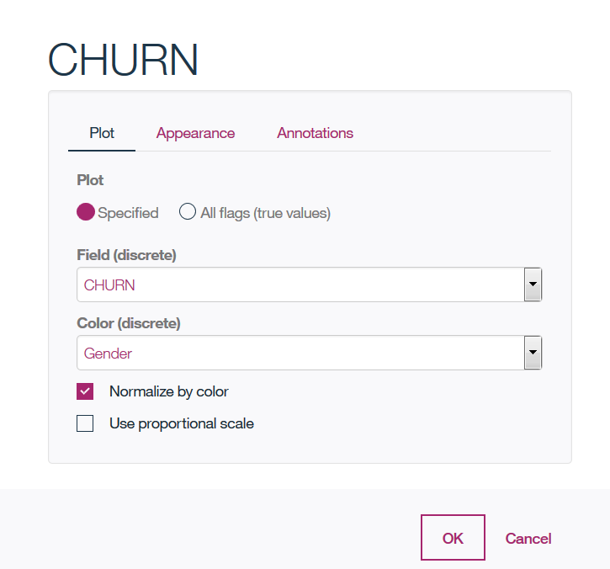

- Output is shown in the Ouputs panel. Double click to display it.

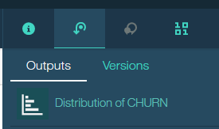

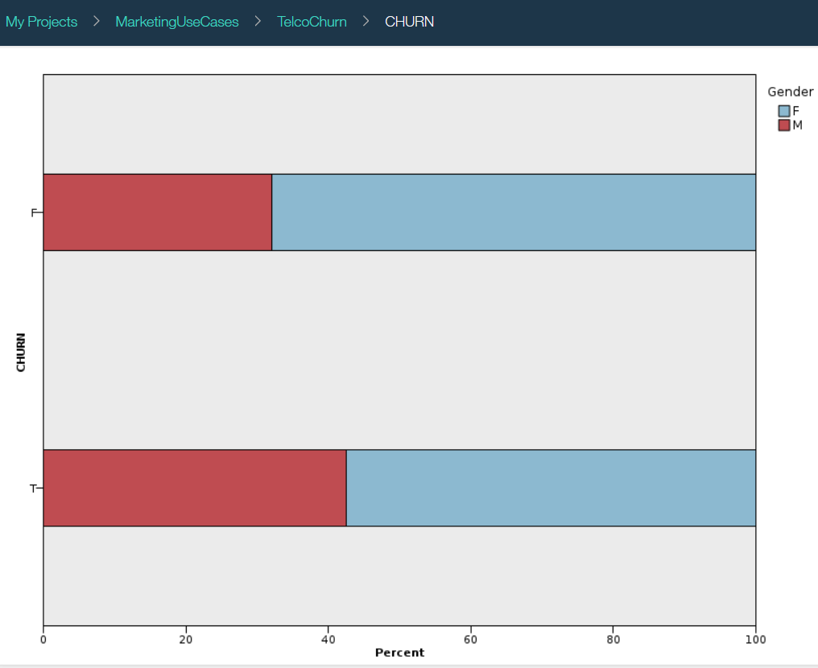

- Next, we are going to build a model for predicting churn. Add a Type node from the Field operations and connect it to the Merge node.

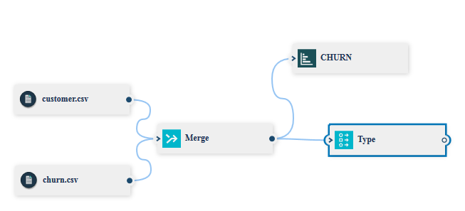

- Double click on the Type node and click Add Columns. On this screen we are selecting the fields that will be used for modeling.

- Select all fields with the exception of ID (because ID is not a predictor for customer churn). Return back to the main screen and change Role of CHURN field to Target and Measure to Flag because that’s the value we would like to predict.

Click OK.

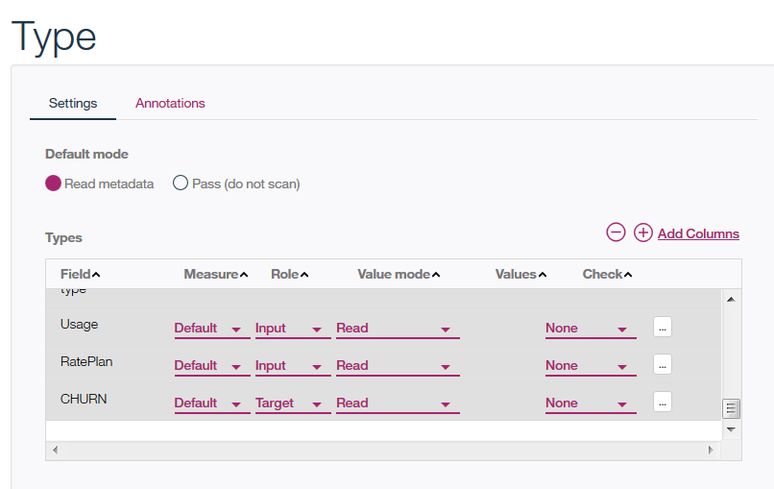

- From the Field Operations add the Partition node and set the Training Partition to 70 and the Testing Partition to 30.



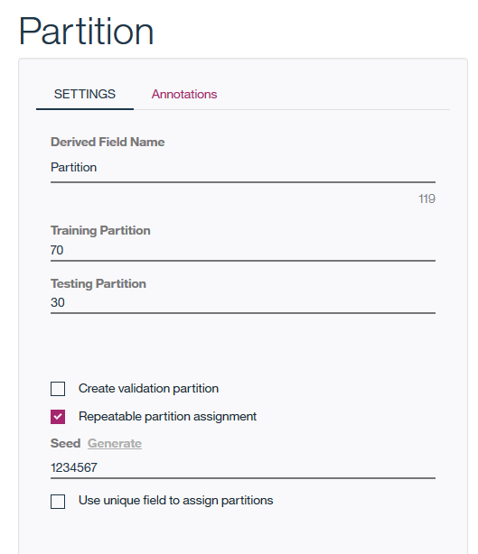

- Add the C5 node from the Modeling tab. The C5 is a popular decision tree algorithm.

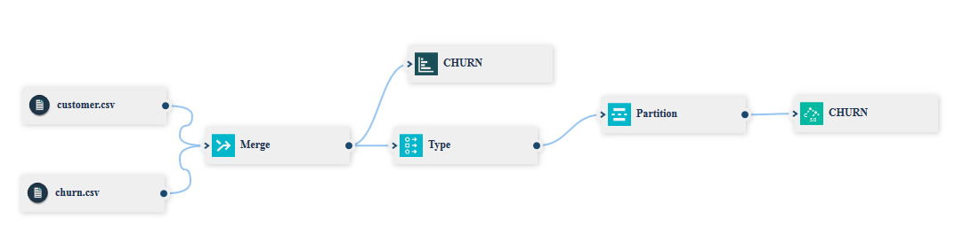

- Right click on the C5 node on the canvas (CHURN) and select Run.

- Model building will take a few minutes. When model building is done, you’ll see a model node on the canvas.

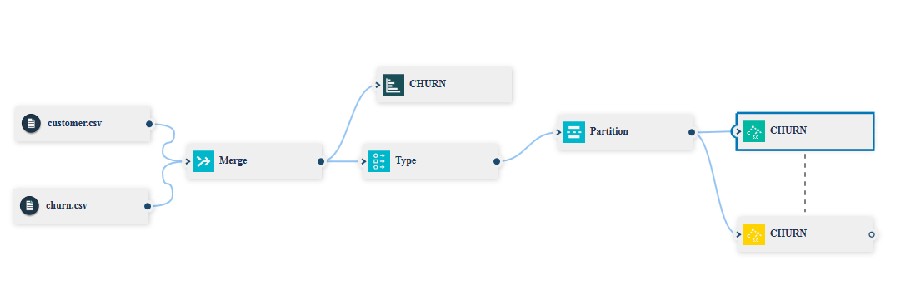

- Right click on the model nugget and select View Model. Explore the model. For example, Top Decision Rules tab shows the combination of predictors that result in specific customer churn value.

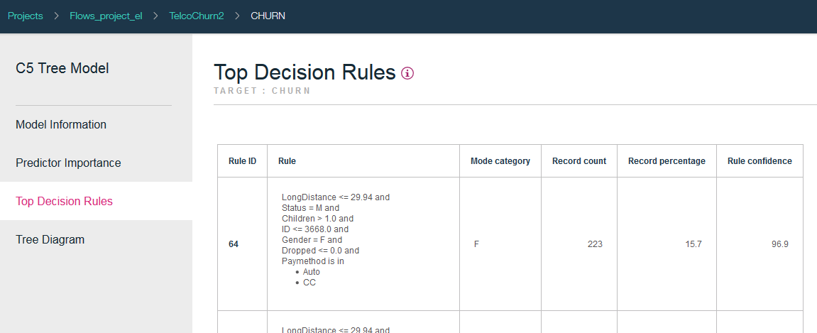

- Finally, add a Table (from Outputs tab) and connect it to the model node.

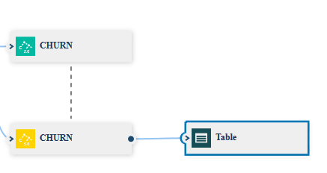

- You can run the entire stream by clicking the Run icon (arrow) in the menu bar. When the stream runs, it scores the data and writes the output to the Table.

Table output can be viewed by clicking on the Table in the Outputs view.

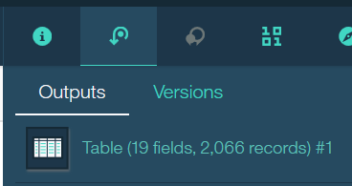

- Scroll all the way to the right and you’ll see two values generated by the model – the predicted value ($C-CHURN) and the confidence in the prediction ($CC-CHURN)

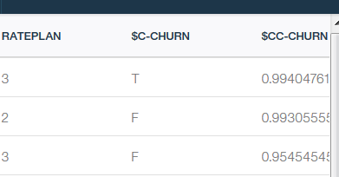

- Optionally, you can add the Analysis (Output tab) the Filter node (Field Operations tab).

  - Connect the Analysis node to the model node. It shows the accuracy of the model (Run the stream and review the output)

  - Connect the Filter node to the model node before the Table. You can use it to filter out all fields with the exception of ID and the two fields generated by the model - ($C-CHURN) and ($CC-CHURN)

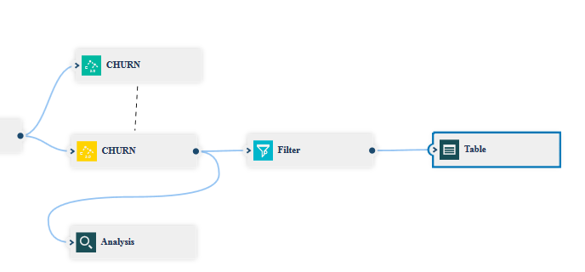

Analysis node output

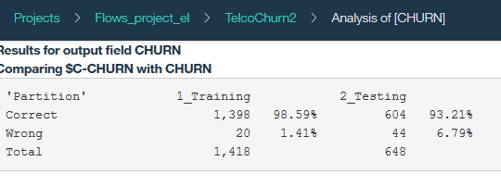

Filtered table output

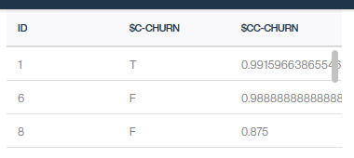

You have finished developing a model to predict customer churn.

Note: At this time SPSS stream deployment capabilities are not yet available in DSX Local. When deployment capabilities are available, you will be able to deploy the Modeler stream for batch and online scoring.

